QUICK LINKS
FOR SC/ST CELL - UCOST
Sr. No. | Link Name | Link | Logo
1 | National Portal of India | https://www.india.gov.in/ | 
2 | Department of Science & Technology, Government of India | https://dst.gov.in/ | 
3 | India Science, Technology & Innovation Portal | https://www.indiascienceandtechnology.gov.in/ | 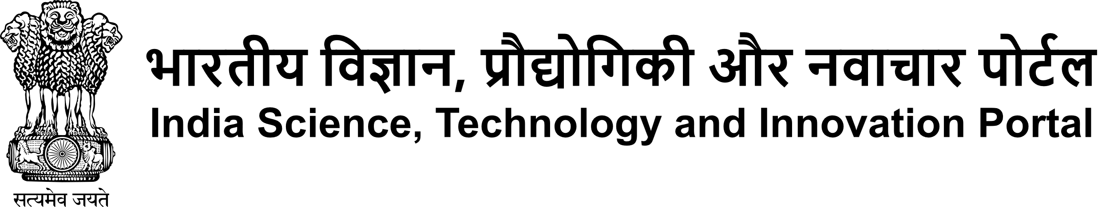
4 | Council of Scientific & Industrial Research | http://www.csir.res.in/ |   Council of Scientific & Industrial Research (CSIR)  वैज्ञानिक एवं औद्योगिक अनुसंधान परिषद  Ministry of Science & Technology, Govt. of India  विज्ञान और प्रौद्योगिकी मंत्रालय, भारत सरकार
5 | Government of Uttarakhand | https://uk.gov.in/ |   उत्तराखंड सरकार  Government of Uttarakhand
6 | Department of Information Technology, Good Governance and Science Technology, Government of Uttarakhand | https://it.uk.gov.in/ | 
7 | Uttarakhand State Council for Science and Technology | https://ucost.uk.gov.in/ | 
8 | Directorate of Tribal Welfare, Government of Uttarakhand | https://tribalwelfare.uk.gov.in/ | 